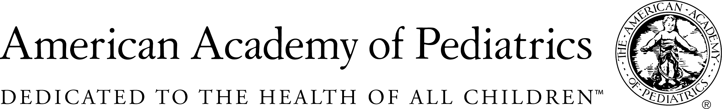

Healthy People 2020 Grant Program for Chapters
Empowering Families, the Media, or Communities to Address the Mental Health Crisis of Children and Youth

Please type your responses using the form fields provided in the template. For more information, please refer to the Request for Proposals. Final submissions must be sent electronically.

Program name

AAP chapter

As the chapter’s primary contact pediatrician, I describe myself as a(n)

Practicing community-based pediatrician Academic pediatrician Medical director
Hospital-based pediatrician Public health pediatrician Pediatric subspecialist
Other

Primary contact pediatrician
Name | Street Address
Title | City
Phone | State
Fax | Zip Code
E-mail

Secondary contact person (if applicable)
Name | Street Address
Title | City
Phone | State
Fax | Zip Code
E-mail

IMPORTANT:
Check here to verify that this application was reviewed by Chapter President (Required)

Print Name of Chapter President
Date
checklist

Program addresses at least one of the outlined Healthy People objectives (AH-3, AH-9, AH-10, AH-11, ECBP-2.3, ECBP-2.4, ECBP-7.4, ECBP-10.2, ECBP-10.3, EMC-1, EMC-2, IVP-41, IVP-42, MICH-34, MHMD-2, MHMD-3, MHMD-4.1, MHMD-5, MHMD-6, MHMD-7, MHMD-10, MHMD-11.2)
Application has been reviewed by the chapter president (Please check the box on page 1 of the application indicating that the chapter president has reviewed and approved the application)).
Project proposals that require institutional review board (IRB), may only be considered if the approval process will not extend the project beyond the 18 month grant cycle.
Application proposed budget does not include capital expenses.
Application includes a letter of support from the chapter.
Application is received by email by 11:59 pm on March 30, 2018.

Do you have Grant Compliance Procedures in place at the chapter level?
YES NO

*Please note: Grant compliance is strongly encouraged, but not required for the grant.
To review a sample grant management process provided with permission from District II New York, please click on the following link:

https://www.aap.org/en-us/my-aap/chapters-and-districts/Resources/Documents/grantmanagementprocessD2.pdf

Program summary

Proposal summary/abstract, including which Healthy People 2020 objective(s) the proposal addresses and the overall goals of the program (250 word limit)

Describe the following

1. Applicant organization (Total Points = 10) (Include the role of the chapter in this proposal, and how the present program fits into the chapter’s activities and strategic plan, and has potential for broad chapter membership participation.) (250 word limit)

2. The target population focuses on populations with health disparities who are adversely affected by obstacles that impede their ability to maintain or improve their own health. (Total Points = 15) (Include the number of children to be impacted and demographic data describing the hard to reach/high risk populations with barriers to achieving HP2020 objectives.) (250 word limit)

3. Describe the specific activities, highlighting any innovation and creativity, and how they will achieve the Healthy People 2020 objective(s). (Total Points = 15) (750 word limit)

4. Identify and describe involvement of community collaborative partners for this program. (Total Points = 10) (eg, grassroots associations, parents, faith-based groups, local businesses, local public health service agencies, school boards, hospitals). (250 word limit)

5. Describe the timeline for accomplishing your goals and objectives. (Total Points = 10) (not to exceed 18 months)
Program Goals and Objectives | Months
 | 3 | 6 | 9 | 12 | 15 | 18

6. Budget detail and justification—not to exceed $20,000 (See Request for Proposals for a sample budget.) (Total Points = 10)

Note: AAP Chapter is the fiscal agent for the grant. Explain what resources, if any, the chapter will allocate to this program. PLEASE NOTE THAT PROPOSALS MAY NOT INCLUDE CAPITAL EXPENSES.

Activity | Description/Formula | $ Amount
TOTAL Amount Requested |  | $

7. Describe how you will measure the achievement of your goals and objectives. (Total Points = 15) (250 word limit)

8. Identify the long-range goals for this program and plans for sustainability and replication in other communities beyond the grant period, including potential sources of future funding. (Total Points = 15) (250 word limit)

Proposals must be received electronically via e-mail by March 30, 2018

Applications must be sent electronically to hhurley@aap.org.

The Healthy People 2020 Grant Program for chapters is sponsored by the AAP Friends of Children Fund.

